The Imagination Lab invites you
this weekend,
November 7th and 8th, from noon to 4 p.m.,
to an open-air event on their balcony.

Meet the entire collection of over 4,000 books
for sale inside. Fifty categories!
You’ll surely find a book for your collection.
Covid-19 Guidelines observed.

A free book from the Balcony Books to each visitor! You choose!

Saturday November 7 and Sunday November 8, noon to 4
The Imagination Lab 621 West Line Street, Suite 204, Bishop, California
in the Town & Country Center across from Dwayne’s Pharmacy, downtown Bishop, California
760-872-2446 www.fb.com/groups/TheImaginationLab

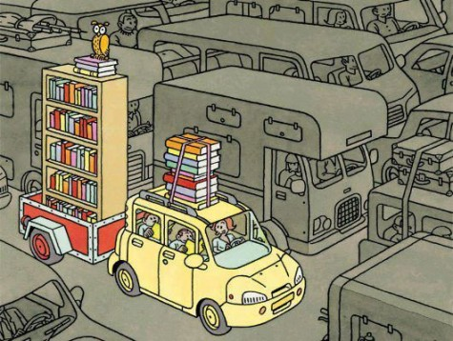
“Art and literature are deeply entangled with our understanding of the social world.” from The Impact Blog

